AI Skills Transformation Trends and Enterprise Learning Strategy: 2026 Update with Implementation Roadmap

Executive Summary
Enterprise AI investments are failing to deliver returns primarily because organizations misallocate resources toward technology while neglecting the workforce capability that drives 70% of AI value. BCG’s 10-20-70 model [1] reveals that people, process, and organizational change—not algorithms or infrastructure—determine whether AI deployments generate business impact. This finding explains why over 60% of companies using generative AI report no significant bottom-line improvement [2] and why 95% of unstructured AI experiments produce zero returns [3].
The clearest evidence of what works comes from the 6% of large companies qualifying as AI-adoption leaders, whose workforces contain 13% AI-skilled employees versus just 1% at laggards [1]. These leaders outperform peers by 9.3 percentage points in total shareholder return and plan to upskill more than 50% of their workforce [1, 4]. Their approach follows a structured Foundational → Applied → Embedded learning architecture [1] delivered through focused 90-180 day sprints tied to measurable business missions rather than scattered experimentation [1, 5]. Organizations with mature upskilling programs are nearly twice as likely to report significant positive AI ROI [6].
The most actionable insight is that middle management activation—not broader training volume—is the highest-leverage intervention. Mature organizations show 88% of managers role-modeling AI use versus 25% at laggards [1], and without managerial guidance, 66% of frontline workers gaining productivity from AI have no direction on reinvesting that time [1]. Enterprises should rebalance investment toward the people dimension, deploy role-based tiered learning with sprint-based proof points, embed responsible-AI governance aligned to EU AI Act timelines [7], and equip managers to translate strategy into daily workflow change.

Introduction: The AI Skills Imperative in 2025-2026
The enterprise AI landscape in 2025-2026 presents a striking paradox: while approximately 80% of companies now use generative AI in at least one business function, more than 60% report seeing no significant bottom-line impact [2]. Enterprise-wide AI implementation has doubled year over year, with 24% of organizations reporting full-scale adoption in 2026, up from 12% in 2025 [8]. Yet this rapid technology deployment has not translated into proportional value creation, revealing a fundamental misalignment between investment priorities and the true drivers of AI-powered transformation.
The skills dimension of this challenge is acute. According to the World Economic Forum, 94% of leaders face AI-critical skill shortages today, with one in three reporting gaps of 40% or more [9]. Far from eliminating jobs, AI has already created 1.3 million new roles according to LinkedIn data [10], while AI engineering positions surged 255% year over year and U.S. postings for AI and machine learning roles jumped 163% from 2024 to 2025 [11]. A recent McKinsey survey highlights that 75% of U.S. workers anticipate their roles changing due to AI in the coming five years, yet only 45% have gone through a recent upskilling program [12].
BCG’s foundational insight reframes the entire conversation: their 10-20-70 model attributes AI value as 10% technology, 20% algorithms and data, and 70% people, process, and organizational change [1]. This finding demands that enterprises redirect their transformation strategies from technology-centric deployments toward workforce-centric learning and capability building. This report synthesizes the latest research and best practices into a comprehensive enterprise learning and certification strategy with actionable recommendations for capturing the full value of AI investments.

The AI-Adoption Leader Benchmark: What Separates the 6%
BCG’s outside-in analysis of more than 600 U.S. public companies with market caps above $5 billion identified only 6% as AI-adoption leaders, scoring across technology, talent, and deployment pillars equally [1]. These leaders dramatically outperform their peers: their industry-adjusted total shareholder return was 9.3 percentage points above median over three years, with revenue growth 10 percentage points higher and margin expansion 6 percentage points higher [1]. Critically, this outperformance is driven by revenue growth and margin expansion rather than investor hype [13].
The workforce composition difference between leaders and laggards is stark. At AI-adoption leaders, 13% of workers have AI-related skills compared with just 1% at laggards [1]. Future-built companies plan to upskill more than 50% of employees on AI, compared with only 20% for laggards, and they are putting the organizational resources in place to support those goals [4]. Despite these clear benchmarks, McKinsey finds that almost all companies invest in AI but just 1% believe they are at maturity [14].
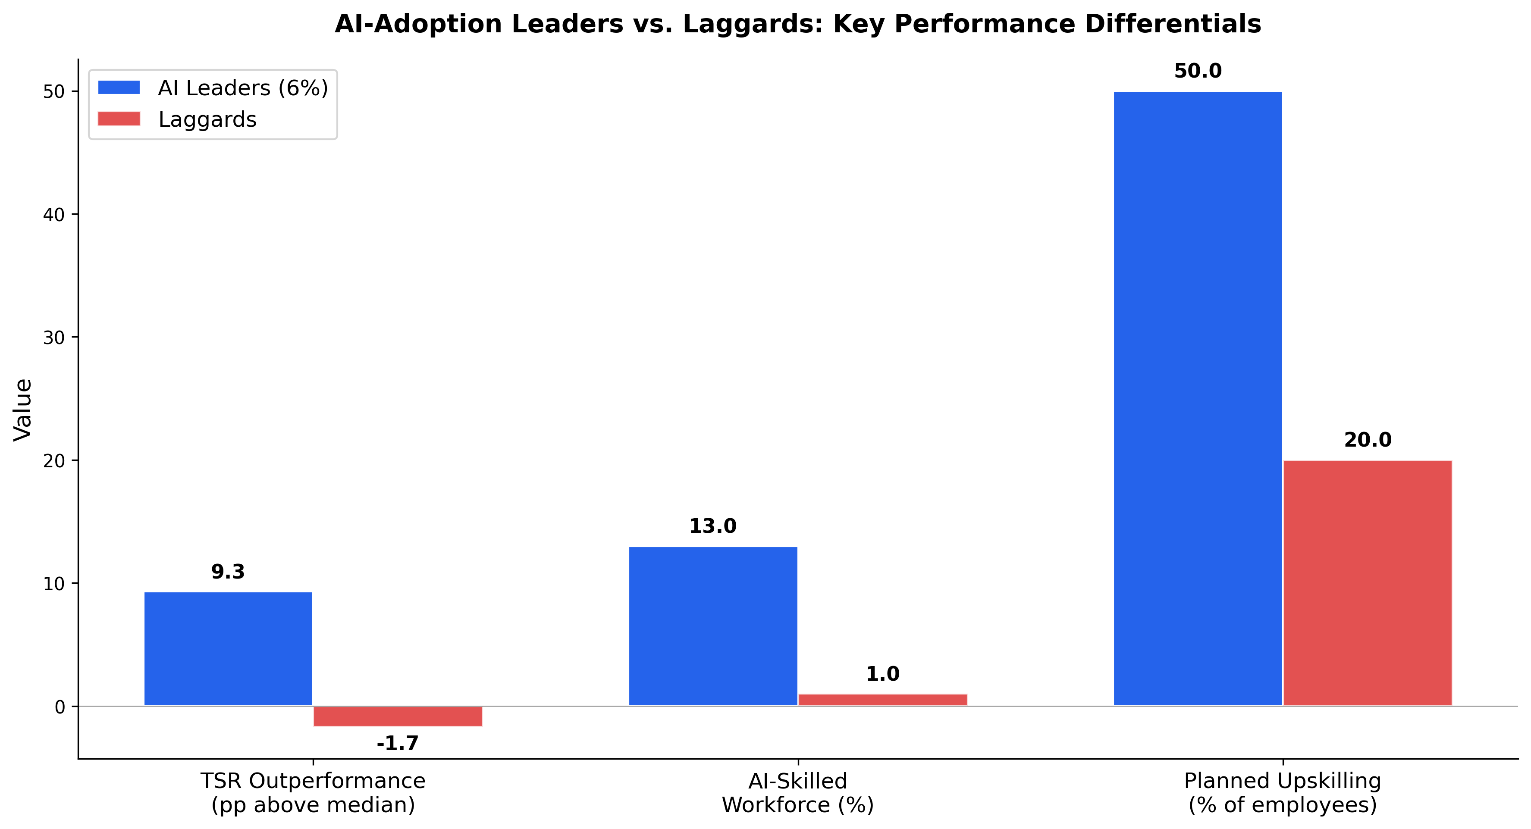
AI-Adoption Leaders vs. Laggards Performance Comparison
Chart Explanation: This chart illustrates the dramatic performance gap between the 6% of companies qualifying as AI-adoption leaders and laggards across three dimensions: total shareholder return outperformance (9.3pp vs. -1.7pp), AI-skilled workforce percentage (13% vs. 1%), and planned upskilling investment (50%+ vs. 20%) [1, 4].
The implications are clear: the path to AI leadership runs through workforce capability, not technology acquisition alone. Organizations that treat AI transformation as primarily a technology deployment challenge—neglecting the 70% people and process component—consistently underperform [1].

Role-Based Learning Design Framework
Three-Tier Curriculum Architecture. Effective enterprise AI learning programs follow a Foundational → Applied → Embedded progression that maps to increasing depth of workflow integration [1]. The Foundation tier covers AI fluency, approved tools, safe use, privacy and security, evaluation, bias awareness, judgment, and escalation protocols. The Applied tier moves into real workflow practice, simulations, role play, use-case sprints, coaching, and evaluated artifacts. The Embedded tier sustains transformation through communities of practice, job aids, standard operating procedures, incentives, and performance expectations [1].
Five-Level AI Fluency Maturity Model. Within this framework, individual capability progresses through five levels: Aware, Fluent, Applied, Builder, and Leader [1]. Current enterprise reality reveals a significant concentration at lower maturity levels—more than 85% of employees remain at task assistance and delegation stages, while fewer than 10% have reached semiautonomous collaboration or beyond [1]. This distribution underscores the scale of the upskilling challenge and the need for structured progression pathways.
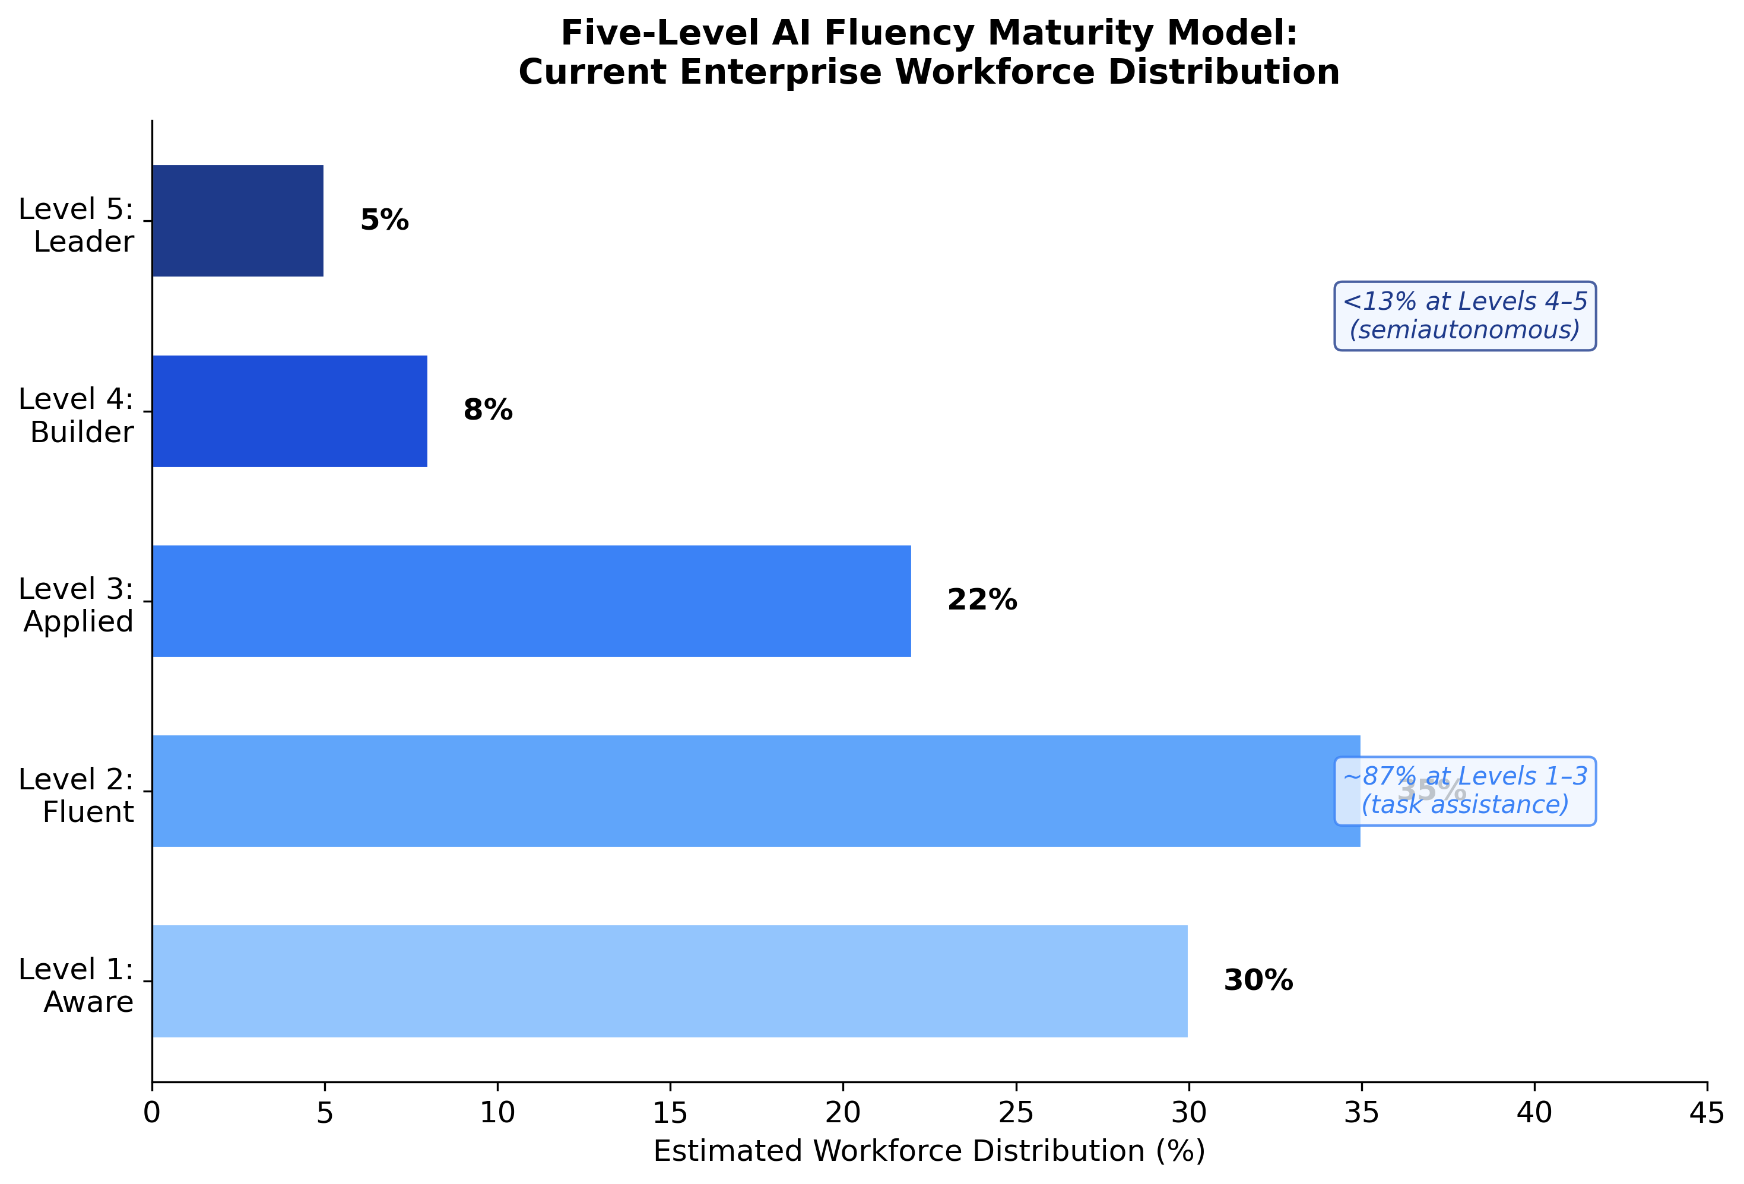
Five-Level AI Fluency Maturity Model Distribution
Chart Explanation: This chart shows the estimated distribution of enterprise workers across the five AI fluency maturity levels. The vast majority (~87%) remain at Levels 1–3 (task assistance), while fewer than 13% have progressed to semiautonomous collaboration at Levels 4–5 [1].
Training Intensity and Delivery Mode Matter. BCG’s 2025 AI at Work research found that only 36% of employees felt properly trained in AI use, but regular AI usage was markedly higher among employees who received at least five hours of training, especially when that training included in-person support and coaching [15]. This finding validates the need for structured, supported learning experiences rather than self-directed content consumption alone.
The role-based design must also account for audience stratification in responsible AI training: free vendor academies provide baseline AI literacy, enterprise learning platforms deliver hands-on skills with scored completion records for audit compliance, and specialist governance courses serve reviewers who approve AI use cases [16].

Implementation: 90-180 Day Proof Points and Pilot-to-Scale Pathways
Rapid Deployment Methodology. The research identifies a clear three-phase playbook for demonstrating AI skills value within compressed timelines. Month 1 focuses on identifying high-friction tasks and writing simple rules. Month 2 tests tools that have already proven effective elsewhere. Month 3 measures outcomes with real customers, then keeps what works and eliminates what does not [5]. This approach is complemented by selecting three to four business missions with measurable 90–180-day proof points, using 6–10 week use-case sprints with weekly quality, risk, and results reviews, and applying 30/60/90-day scale-adjust-stop criteria [1].
Depth Over Breadth. A critical lesson from recent experience is that scattered experimentation destroys value. Harvard Business Review reports that a MIT Media Lab/Project NANDA study found 95% of investments in generative AI have produced zero returns when deployed as unstructured experiments [3]. Successful enterprises avoid running many scattered pilots and instead pick one area and go deep, building genuine capability before expanding [3].
Three Horizons of Transformation. McKinsey’s 2026 global survey identifies three horizons for scaling AI impact [17]. The first horizon, Enablement, provides individual employees access to general-purpose AI tools. The second, Automation, automates and improves existing cross-functional workflows using AI at scale. The third, Reinvention, creatively reimagines how work gets done by redesigning roles, workflows, and operating models to leverage AI’s full potential [17]. Each horizon requires progressively deeper skills and organizational change, reinforcing the need for the tiered learning framework described above.
Phase | Timeline | Activities | Success Criteria
Identify & Baseline | Month 1 (Days 1-30) | Map high-friction tasks, write simple rules, select 3-4 business missions [1, 5] | Friction points documented, baseline metrics established
Test & Sprint | Month 2 (Days 31-60) | 6-10 week use-case sprints, test proven tools, train focused role groups [1, 5] | Weekly quality/risk reviews completed, artifacts evaluated
Measure & Scale | Month 3 (Days 61-90) | Measure outcomes with real customers, apply scale-adjust-stop criteria [1, 5] | Measurable proof points achieved, good practice codified
Expand | Days 90-180 | Scale successful patterns, expand to additional business missions [1] | 90-180 day evidence documented across multiple missions
Table: 90-180 Day Implementation Playbook
How AWS Training and Certification Accelerates This Pathway. AWS provides purpose-built programs that map directly to each phase of the 90-180 day implementation playbook. In the Identify & Baseline phase, the free AWS Learning Needs Analysis helps organizations pinpoint skill gaps preventing them from achieving their objectives, establishing a clear starting point before sprints begin [18]. During the Test & Sprint phase, the AWS Skills Guild program—structured around three pillars of Excitement, Enablement, and Advocacy—delivers hands-on collaborative learning tailored to varying expertise levels, enabling teams to immediately apply cloud and AI skills [19, 20]. AWS Skill Builder Team subscriptions ($449/seat/year) provide access to over 330 AI learning resources with hands-on labs in real AWS environments, supporting rapid skill deployment during focused sprints [21, 22].
For the Measure & Scale phase, AWS’s Five V’s Framework (Value, Visualize, Validate, Verify, Venture) offers a field-tested methodology that has moved 65% of Generative AI Innovation Center customer projects from concept to production, with some launching in as few as 45 days [23]. Enterprise case studies validate this accelerated timeline: Holcim achieved an 85% participation rate and 90% reduction in manual invoice processing through the AWS Skills Guild [20], while Globe achieved a 25% year-over-year increase in AWS Certifications [24] and Pearson equipped nearly 2,000 employees across three continents [25]. A Forrester Total Economic Impact study found that very large enterprises realized a 234% ROI from AWS Training and Certification services, while an ESG study of 1,000 learners found 84% reported improved on-the-job efficiency [26, 27].

Certification Programs and Learning Delivery Best Practices
The Maturity-ROI Connection. In 2026, 82% of enterprise leaders say their organization provides some form of AI training, yet only 35% have a mature, organization-wide AI upskilling program [6]. The gap matters enormously: organizations with mature workforce-wide upskilling programs are nearly twice as likely to report significant positive AI ROI [6]. Time constraints (35%) and lack of budget (31%) remain the top barriers to improving AI skills, with 26% of leaders citing difficulty reporting on the ROI of training programs as a key challenge [6].
Workflow-Embedded Adaptive Learning. The most effective programs move beyond traditional course-based delivery to embed learning in the flow of work. ROI begins when learning changes behavior inside a meaningful workflow, with effective programs tailoring depth to specific jobs, embedding practice in the flow of work, and evolving paths as tools change [15]. This approach measures impact across four categories: productivity (cycle time, throughput, time saved), quality (fewer errors, better decisions), labor leverage (more value from existing teams), and strategic speed (time from experimentation to scaled execution) [15]. Notably, McKinsey found that fewer than one in five organizations track well-defined KPIs for generative AI solutions [15].
AI-Native Learning Platforms. The enterprise learning technology market is rapidly transforming around AI-native platforms. According to Josh Bersin, the big use cases for AI in corporate training include dynamic content generation, AI-powered coaches and scenarios, AI-fueled needs analysis, AI-generated skills models, AI-powered skills assessments, and conversational learning interfaces, with leading vendors including Sana, Docebo, Cornerstone Galaxy, Arist, Uplimit, and 360Learning [28].
Enterprise Case Studies. Leading organizations demonstrate what mature programs can achieve. Visa’s AI-embedded practice approach led to a 78% increase in seller confidence, while 83% of leaders saw value in sellers using the program [15]. New York Life upskilled 12,000 employees in AI, now fills 33% of roles internally, and has logged more than 15,000 hours of AI learning [15]. These results validate the workflow-embedded, role-specific approach over generic training deployments.
Connection to Strategic Roadmap. The certification and learning delivery practices outlined above directly enable the strategic recommendations in this report’s roadmap. The maturity-ROI connection—where organizations with mature upskilling programs are nearly twice as likely to report significant positive AI ROI [6]—validates the recommendation to deploy role-based tiered learning with 90-day milestones. AWS Training and Certification provides the infrastructure to operationalize this connection: the tiered certification architecture progresses from AWS Certified AI Practitioner at the foundational level, through ML Engineer Associate at the applied level, to Generative AI Developer Professional for advanced practitioners [29, 30, 31]. This progression maps directly to the Foundational → Applied → Embedded curriculum architecture recommended in the roadmap [1]. The workflow-embedded measurement approach—tracking productivity, quality, labor leverage, and strategic speed [15]—connects to the roadmap’s emphasis on measuring behavior change rather than course completion. AWS Skill Builder’s admin dashboards provide completion tracking, assessment scores, and team-level analytics [1], which organizations should integrate with operational metrics to achieve the full four-layer measurement model recommended in the strategic roadmap.

Responsible AI Governance and Guardrails
AWS Eight-Dimension Framework. AWS defines eight core dimensions of responsible AI that form the foundation for enterprise governance training: fairness, explainability, privacy and security, safety, controllability, veracity and robustness, governance, and transparency [32]. These dimensions provide a comprehensive structure for embedding ethical considerations into every stage of AI development and deployment, from pretraining through production use.
Regulatory Acceleration. The EU AI Act’s phased enforcement is making governance training a board-level priority. Bans on prohibited practices took effect in February 2025, obligations for general-purpose AI models in August 2025, and most remaining obligations—including transparency duties and rules for high-risk systems—apply from August 2026 [7]. This regulatory timeline creates urgent demand for governance-capable workforces across all organizations operating in or serving European markets.
Embedding Governance into Workflows. The research is clear that privacy, security, bias, oversight, transparency, and inclusion must be embedded into workflows rather than added as separate compliance layers [1]. Effective implementation requires mapping AI-assisted, automated, and human-owned tasks; establishing data and governance boundaries; and implementing review thresholds, auditability, escalation protocols, and prohibited-use boundaries [1]. Amazon’s responsible AI pipeline demonstrates enterprise-scale capability building, supported by over 70 internal and external RAI tools, more than 500 research papers, and tens of thousands of hours of employee training [33].
Three-Tier Governance Training. Organizations are addressing AI ethics skills gaps through stratified training: free vendor academies for baseline AI literacy, enterprise learning platforms for hands-on skills with scored completion records for audit compliance, and specialist governance courses for the people who review and approve AI use cases [16]. This tiered approach ensures that governance knowledge is proportionate to decision-making authority and risk exposure.
Connection to Actionable Next Steps. The responsible AI governance framework described above feeds directly into the strategic roadmap’s recommendation to “Build Responsible AI Governance into Learning Design from Day One.” The eight dimensions of responsible AI [32] provide the content architecture, while the EU AI Act enforcement timeline [7] establishes the urgency and sequencing for implementation milestones. AWS supports this connection through specific training and compliance resources: the AWS Certified AI Practitioner validates foundational understanding of responsible AI principles [29], the AWS Well-Architected Responsible AI Lens provides a comprehensive framework for implementing responsible practices throughout the AI development lifecycle [34], and the updated AWS User Guide to Governance, Risk, and Compliance for Responsible AI Adoption (May 2026) offers practical guidance across governance, risk management, and compliance dimensions [35]. For organizations operating in European markets, AWS was among the first signatories of the EU AI Pact and provides AI Service Cards and guardrails to help customers meet obligations under the phased enforcement timeline [36]. The Generative AI Learning Plan for EU Governments has already empowered more than 5,500 professionals with essential AI skills [35], demonstrating how governance-aligned training can be deployed at scale. These AWS resources enable organizations to move from the governance principles outlined in this section to the concrete implementation actions specified in the roadmap—embedding compliance into sprint-based learning rather than treating it as a separate workstream.

Change Management and Leadership Alignment
Leadership as the Primary Barrier. The most significant finding from recent research is that the biggest barrier to scaling AI is not employees—who are ready—but leaders who are not steering fast enough [14]. Workforce readiness is emerging as the key barrier to scaling AI, as demand for process, data, security, and change management skills is outpacing talent development [37]. This leadership gap manifests in concrete behavioral differences: 88% of managers role-modeled AI use in mature organizations versus only 25% at laggards [1].
The Manager Capability Gap. Managers translate organizational intent into team norms and daily practice, making their engagement critical to transformation success. Yet the current state reveals a troubling disconnect: 42% of regular frontline AI users reported saving the equivalent of one workday weekly, but 66% had limited or no guidance on reinvesting that time [1]. Without managerial direction on how to redirect productivity gains toward higher-value work, organizations forfeit much of the potential benefit from AI adoption.
Upskilling as Three-Dimensional Change Management. McKinsey recommends treating AI upskilling as a change management effort across three dimensions: AI literacy (shared baseline fluency), AI adoption (embedding tools into workflows by redesigning roles and incentives), and AI domain transformation (domain-specific use cases for competitive advantage) [38]. Most companies spend disproportionately on literacy because it is visible and easy to measure, while fewer invest in adoption, which is messier and requires leadership courage [38]. This imbalance explains why broad training investments often fail to produce measurable business outcomes.
Productivity Gains Require Organizational Redesign. Carefully controlled studies show measurable productivity gains for workers assisted by AI: software developers produced around 26% more completed tasks, call-centre agents resolved 14% more customer issues per hour, and mid-level professionals spent around 40% less time on routine writing and analysis [39]. However, translating individual productivity into organizational value requires deliberate redesign of workflows, roles, and performance expectations—the domain transformation dimension that most organizations underinvest in.
Connection to Next Steps and Recommendations. The leadership and change management challenges identified above directly inform two critical recommendations in the strategic roadmap: “Activate Middle Management as Transformation Catalysts” and “Treat Transformation as a Multi-Year Journey Across Three Horizons.” The 88% vs. 25% role-modeling differential [1] establishes the evidence base for prioritizing manager activation, while the three-dimensional change management framework (literacy, adoption, domain transformation) [38] provides the structure for sequencing investments across the roadmap’s phases. AWS Training and Certification addresses the leadership gap through targeted offerings: “Generative AI for Decision Makers” and “Planning a Generative AI Project” courses equip leaders with strategic AI understanding without requiring deep technical skills [1]. For the broader organizational change dimension, the AWS Organizational Change Acceleration (OCA) 6-Point Framework implements an end-to-end process focusing on organizational culture, operating model, workforce, and change leadership [40]—directly supporting the roadmap’s call for deliberate workflow redesign. Organizations that lack internal capacity for middle-management AI coaching can engage AWS Professional Services or AWS Training Partners to design custom programs around the 6–10 week sprint model [1, 41], ensuring that the manager activation recommendation translates into concrete, time-bound action.

Actionable Recommendations and Strategic Roadmap
Based on the synthesis of current research and enterprise best practices, the following strategic recommendations provide a roadmap for organizations seeking to close the AI skills gap and capture the full value of their AI investments.
Rebalance Investment According to the 10-20-70 Model. Organizations must shift budget and executive attention toward the 70% people, process, and organizational change component of AI value creation [1]. This means treating workforce transformation as the primary workstream rather than a supporting function of technology deployment. Future-built companies demonstrate this principle by planning to upskill more than 50% of employees [4], recognizing that technology without capable people produces the zero-return outcomes seen in 95% of unstructured AI experiments [3].
Deploy Role-Based Tiered Learning with 90-Day Milestones. Implement the Foundational → Applied → Embedded curriculum architecture [1] with clear progression criteria and 90-180 day proof points [1]. Begin with three to four focused business missions rather than broad experimentation, using 6-10 week sprints to build genuine capability before expanding. Ensure at least five hours of structured training with in-person coaching support to drive regular AI usage [15].
Measure Behavior Change, Not Course Completion. Adopt the four-category measurement framework—productivity, quality, labor leverage, and strategic speed [15]—and establish well-defined KPIs from the outset. Track workflow integration depth and business impact rather than training hours or certification counts. Address the current reality where fewer than one in five organizations track well-defined KPIs for generative AI solutions [15].
Build Responsible AI Governance into Learning Design from Day One. Integrate the eight dimensions of responsible AI [32] into every tier of the learning framework rather than treating governance as a separate compliance exercise [1]. Align training timelines with EU AI Act enforcement milestones [7] and stratify governance depth by role and decision-making authority [16].
Activate Middle Management as Transformation Catalysts. Close the manager capability gap by equipping leaders with clear guidance on reinvesting productivity gains, role-modeling AI use, and translating organizational AI strategy into team-level norms and expectations [1]. The 88% vs. 25% role-modeling differential between mature organizations and laggards [1] demonstrates that manager activation is the single highest-leverage intervention for scaling adoption.
Treat Transformation as a Multi-Year Journey Across Three Horizons. Align expectations with McKinsey’s three-horizon model—Enablement, Automation, and Reinvention [17]—recognizing that each horizon requires progressively deeper organizational change. Invest in the adoption and domain transformation dimensions of upskilling [38], not just literacy, to move beyond the 60%+ of organizations seeing no bottom-line impact from their AI deployments [2].

How AWS Training and Certification Enables This Roadmap
AWS Training and Certification provides a comprehensive ecosystem of programs, certifications, and tools that map directly to each strategic recommendation, enabling organizations to move from strategy to execution with proven, scalable solutions.
For Rebalancing Investment (10-20-70 Model): The AWS Skills Guild is a consultative engagement that develops bespoke cloud and AI enablement initiatives combining formal education with hands-on training, directly addressing the 70% people and process dimension [42]. The program’s three-pillar structure—Excitement, Enablement, and Advocacy—creates self-sustaining learning cultures rather than one-time training events [19].
For Role-Based Tiered Learning with 90-Day Milestones: AWS’s certification architecture maps precisely to the Foundational → Applied → Embedded framework: AWS Certified AI Practitioner for foundational AI fluency [29], AWS Certified Machine Learning Engineer – Associate for applied workflow integration [30], and AWS Certified Generative AI Developer – Professional for embedded, production-ready AI development [31]. The AWS Skill Builder Team subscription provides over 330 AI learning resources with hands-on labs, Meeting Simulator for communication practice, and Cohorts Studio for team-based collaborative learning [21, 43].
For Measuring Behavior Change: AWS Skill Builder’s admin dashboards provide completion tracking, assessment scores, learning plan progress, and team-level analytics [1]. Organizations should integrate these learning metrics with operational data to achieve the full productivity, quality, labor leverage, and strategic speed measurement framework [15]. The AWS Learning Needs Analysis offers a free baseline assessment to identify skill gaps before implementation begins [18].
For Responsible AI Governance: AWS offers tiered governance training from the AI Practitioner certification (which validates responsible AI principles) [29] through the Well-Architected Responsible AI Lens [34] and EU AI Act compliance resources [36]. The AWS User Guide to GRC for Responsible AI Adoption (May 2026) provides practical compliance-aligned guidance [35].
For Activating Middle Management: AWS addresses the leadership gap through “Generative AI for Decision Makers” and “Planning a Generative AI Project” courses [1], while the AWS Organizational Change Acceleration (OCA) 6-Point Framework supports the broader culture, operating model, and change leadership dimensions [40]. Custom programs via AWS Professional Services or Training Partners can be designed around the sprint-based model for manager coaching [1, 41].
For Multi-Year Transformation: The Five V’s Framework (Value, Visualize, Validate, Verify, Venture) provides a proven methodology for scaling from pilots to production—65% of AWS Generative AI Innovation Center projects have transitioned from concept to production using this approach, some in as few as 45 days [23]. Specialized learning plans such as the Agentic AI Technical Learning Plan [44] and role-based career journeys [45] ensure that learning evolves as organizations progress through transformation horizons.
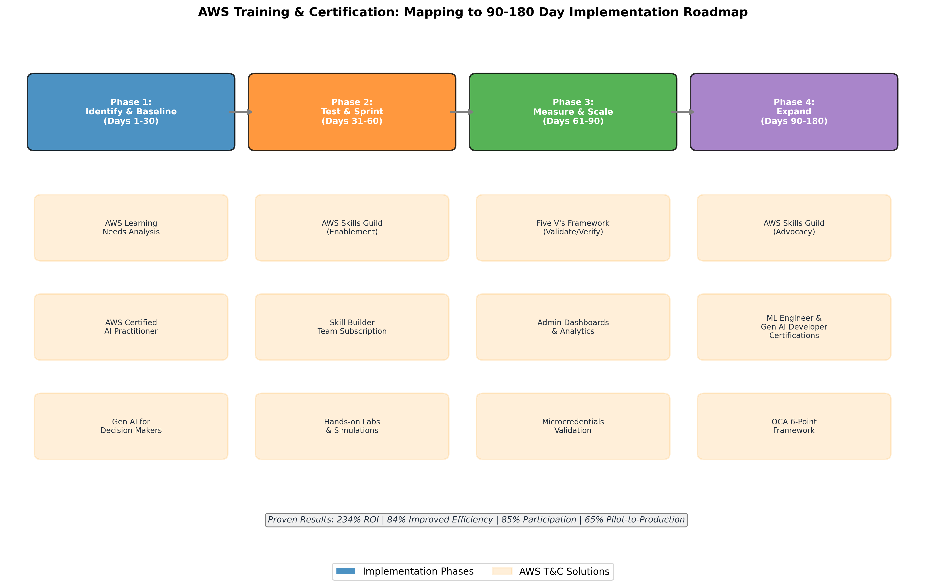
AWS Training and Certification Roadmap Mapping
Chart Explanation: This graphic maps specific AWS Training and Certification solutions to each phase of the 90-180 day implementation roadmap. Phase 1 (Identify & Baseline) leverages the AWS Learning Needs Analysis [18] and foundational certifications [29]. Phase 2 (Test & Sprint) deploys AWS Skills Guild Enablement [19] and Skill Builder hands-on labs [21]. Phase 3 (Measure & Scale) applies the Five V’s Framework [23] with admin dashboards for tracking [1]. Phase 4 (Expand) scales through advanced certifications [30, 31] and the OCA 6-Point Framework [40]. Proven enterprise results include 234% ROI [26], 84% improved efficiency [27], 85% participation rates [20], and 65% pilot-to-production conversion [23].
Strategic Recommendation | AWS Training & Certification Solution | Key Outcome Evidence
Rebalance Investment (10-20-70) | AWS Skills Guild (Excitement, Enablement, Advocacy) [19] | 85% participation, 90% reduction in manual processing [20]
Role-Based Tiered Learning | AI Practitioner → ML Engineer → Gen AI Developer certifications [29, 30, 31] | Structured career progression from foundational to professional [45]
Measure Behavior Change | Skill Builder admin dashboards + Learning Needs Analysis [1, 18] | 84% improved on-job efficiency (ESG study) [27]
Responsible AI Governance | Well-Architected Responsible AI Lens + EU AI Act resources [34, 36] | 5,500+ EU professionals trained [35]
Activate Middle Management | Gen AI for Decision Makers + OCA 6-Point Framework [1, 40] | Custom sprint-based programs via Training Partners [41]
Multi-Year Transformation | Five V’s Framework + Agentic AI Learning Plan [23, 44] | 65% pilot-to-production, some in 45 days [23]
Table: AWS Training & Certification Solutions Mapped to Strategic Recommendations

References
1. AI_Skills_Transformation_Full_Research_Record.docx
2. https://www.mckinsey.com/capabilities/operations/our-insights/a-us-productivity-unlock-investing-in-frontline-workers-ai-skills
3. https://hbr.org/2025/08/beware-the-ai-experimentation-trap
4. https://www.bcg.com/publications/2026/ai-transformation-is-a-workforce-transformation
5. https://blog.superhuman.com/ai-deployment/
6. https://www.datacamp.com/blog/why-traditional-ai-training-isn-t-working-in-2026
7. https://www.solytics-partners.com/resources/blogs/enterprise-ai-governance
8. https://www.teksystems.com/en/insights/infographic/ai-adoption-enterprise-2026
9. https://www.weforum.org/stories/jobs-and-the-future-of-work/ai-s-new-dual-workforce-challenge-balancing-overcapacity-and-talent-shortages/
10. https://www.weforum.org/stories/2026/01/ai-has-already-added-1-3-million-new-jobs-according-to-linkedin-data/?ref=aicl.ghost.io
11. https://www.bu.edu/online/2026/06/27/ai_skills_gap_2026/
12. https://www.mckinsey.com/featured-insights/people-in-progress/the-ai-upskilling-challenge
13. https://www.bcg.com/publications/2026/how-ai-leaders-create-competitive-advantage
14. https://www.mckinsey.com/capabilities/tech-and-ai/our-insights/superagency-in-the-workplace-empowering-people-to-unlock-ais-full-potential-at-work
15. https://www.forbes.com/councils/forbestechcouncil/2026/07/24/adaptive-learning-at-scale-turning-ai-upskilling-into-measurable-roi/
16. https://www.datacamp.com/blog/best-platforms-to-train-teams-on-responsible-ai
17. https://www.mckinsey.com/capabilities/people-and-organizational-performance/our-insights/from-adoption-to-impact-three-horizons-of-ai-transformation
18. https://aws.amazon.com/training/teams
19. https://d1.awsstatic.com/training-and-certification/Enterprise/aws-skills-guild-overview-brochure.pdf
20. https://aws.amazon.com/solutions/case-studies/holcim-case-study/
21. https://aws.amazon.com/training/digital/team-subscription
22. https://aws.amazon.com/training/digital/pricing/
23. https://aws.amazon.com/blogs/machine-learning/beyond-pilots-a-proven-framework-for-scaling-ai-to-production/
24. https://aws.amazon.com/solutions/case-studies/globe-cloud-training-infographic/
25. https://aws.amazon.com/solutions/case-studies/pearson-case-study/
26. https://aws.amazon.com/blogs/training-and-certification/steps-to-implement-cloud-skilling-programs-to-jump-start-digital-transformation
27. https://aws.amazon.com/blogs/training-and-certification/aws-training-and-certification-provide-positive-roi-to-learners/
28. https://joshbersin.com/2026/02/the-enterprise-learning-tech-market-quickly-transforms-around-ai/
29. https://docs.aws.amazon.com/aws-certification/latest/ai-practitioner-01/ai-practitioner-01.html
30. https://docs.aws.amazon.com/aws-certification/latest/machine-learning-engineer-associate-01/machine-learning-engineer-associate-01.html
31. https://aws.amazon.com/cn/blogs/training-and-certification/big-news-aws-expands-ai-certification-portfolio-and-updates-security-certification/
32. https://aws.amazon.com/blogs/machine-learning/incorporating-responsible-ai-into-generative-ai-project-prioritization
33. https://www.amazon.science/blog/building-trust-into-ai
34. https://aws.amazon.com/es/blogs/machine-learning/governance-by-design-the-essential-guide-for-successful-ai-scaling/
35. https://aws.amazon.com/blogs/publicsector/how-aws-skill-builder-is-powering-digital-skills-growth-across-european-institutions/
36. https://aws.amazon.com/blogs/machine-learning/building-trust-in-ai-the-aws-approach-to-the-eu-ai-act/?trk=65d1f2ef-069f-4b14-8689-dcdb14440648
37. https://grantthornton.com/insights/articles/advisory/2026/workforce-gaps-short-circuit-ai-at-emerging-enterprises
38. https://www.mckinsey.com/capabilities/people-and-organizational-performance/our-insights/the-organization-blog/redefine-ai-upskilling-as-a-change-imperative
39. https://www.mckinsey.com/uk/our-insights/uk-blog/the-new-productivity-paradox
40. https://aws.amazon.com/prescriptive-guidance/accelerating-cloud-transformation/
41. https://aws.amazon.com/it/training/digital-training-providers/
42. https://aws.amazon.com/training/teams/enterprise-skills-transformation/skills-guild/
43. https://www.aboutamazon.com/news/aws/aws-ai-certification-learning-tools-skills-development
44. https://aws.amazon.com/blogs/apn/introducing-the-agentic-ai-technical-learning-plan-in-aws-skill-builder/
45. https://aws.amazon.com/blogs/training-and-certification/mapping-your-ai-ml-career-journey/

